

5/11/2018

AWS Project

# InnoMed Case Study

Submitted By: Garima Singh

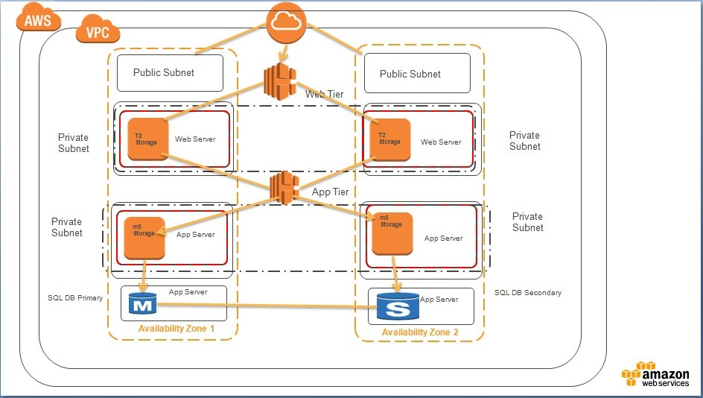

**Architecture Diagram**

1. **Created VPC “InnoMed” and then created 8 subnets for each tier and two public subnets.**

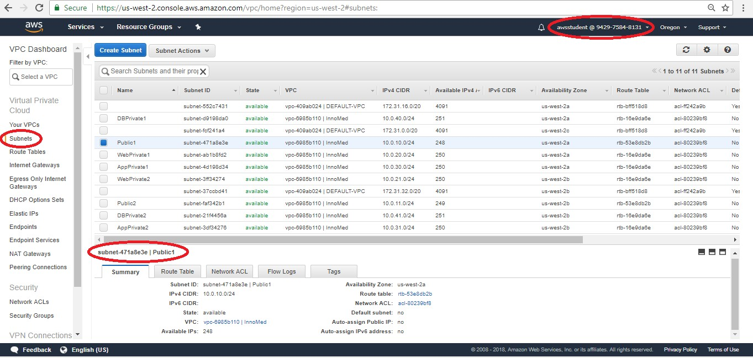

1. **Associated the subnets to the route table and created 5 security groups with the inbound rules.**

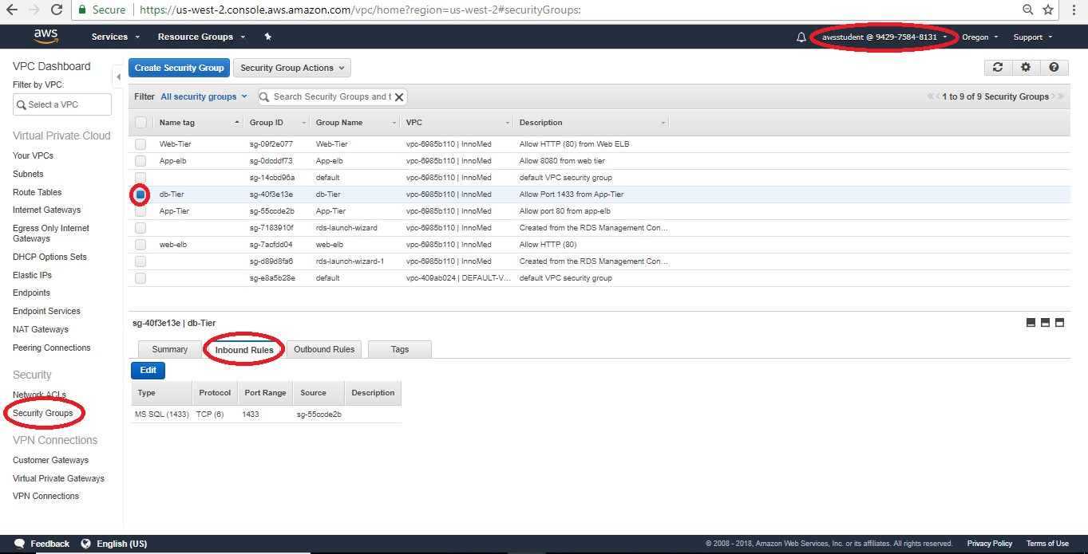

1. **Created two load-balancer for web and app**

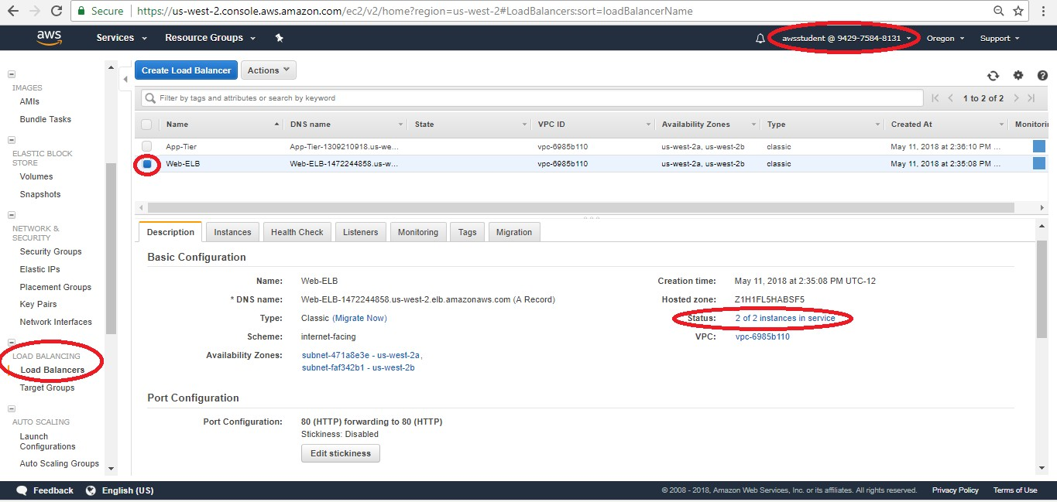

1. **Created two auto-scaling groups with to subnets of different availability zones.**

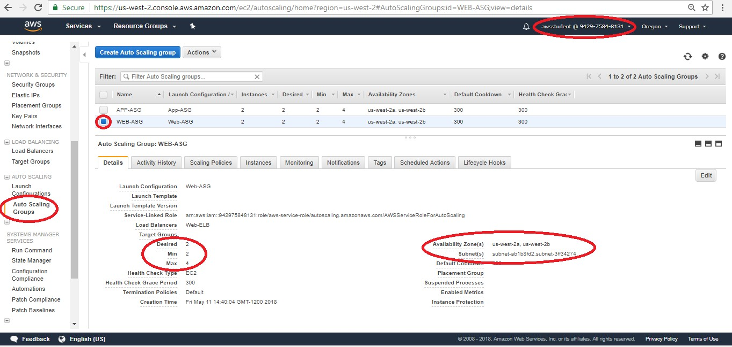

1. **Now we have 4 running instance (Two for web and two for app), terminate all 4 and let autoscaling create four new instances.**

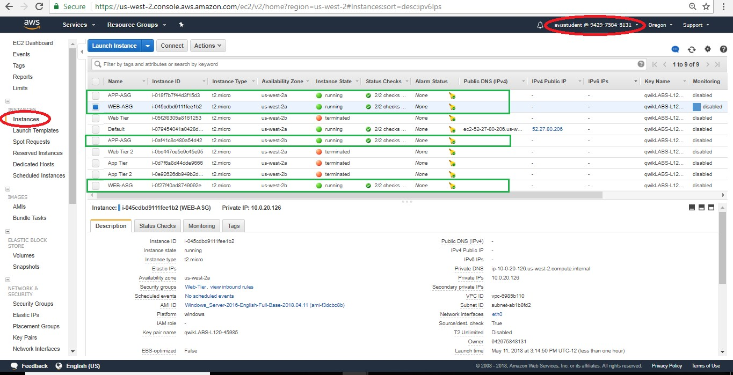

1. **Setting up the DB**

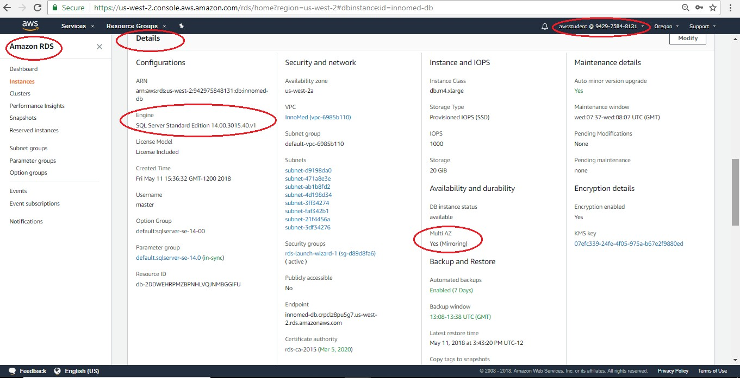

1. **DNS for load balancer (Availablity zone- us-west-2a)**

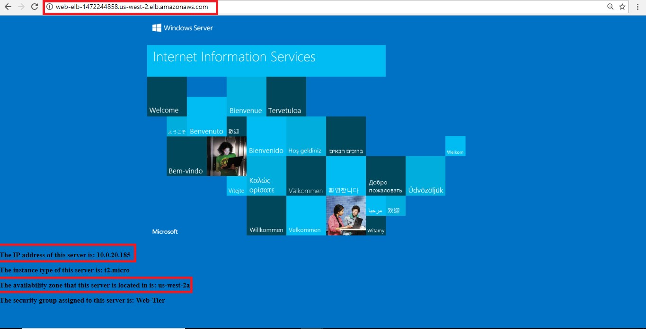

1. **DNS for load balancer (Availablity zone- us-west-2b)**

